Protocol for Initial and On-going Evaluation and Management of the Heart Failure Patient in the Post-Hospitalization Setting.
By: Wayne W Ruppert, CVT, CCCC, NRP

PURPOSE:
The purpose of this protocol is to provide nursing team members (RN, LPN, CNA/PCT, and Home Health Aides) who care for post-acute Heart Failure (HF) patients with an evidence-based guideline for patient assessment and management of heart failure patients recently discharged from a hospital, with a target goal of reduce hospital readmissions by managing heart failure.

OBJECTIVES:

- Establish patient’s hospital discharge diagnosis
- Identify type/ severity of patient’s Heart Failure (systolic / diastolic heart failure)
- Ejection Fraction (EF)
- Maintain compliance with medications ordered
- Low sodium diet (1500mg sodium intake total per day) – unless patient has hyponatremia (sodium <135)
- Fluid restriction 1500ml total fluid intake per day (especially if EF <30 and/or Hyponatremia present).
- Weigh patients daily (at the same time). Preferably first thing in the AM after the patient voids. (no more than 2lb weight gain overnight, or 5lb over 5 days)
- Provide Heart Failure patient education daily (unless patient has dementia / cognitive impairment). Use the attached “Stop Light Form” for patient education (or click this link). The “Stop Light Form” has a scanable QR code that takes patients to the website www.Heart FailureResources.com .

PROTOCOL:

- Perform Initial Patient Evaluation
  - Medical Record review (hospital chart):
    - History and Physical
      - Admission / discharge diagnosis(es) charted by provider
      - Co-morbidities
    - Echocardiogram results
      - Ejection Fraction:
        - 39 or less: Reduced (HFrEF)
        - 40-49: Mid-Range (HF mrEF)
        - 50 and up: Preserved (HFpEF)
      - Valvular stenosis / regurgitation
      - Diastolic Dysfunction
      - Pulmonary Hypertension
    - Laboratory results
      - Na+ (sodium): LOW (<135) or NOT LOW (135 and up)
      - ProBNP (high = 300 and up) note: nearly all HF patients had HIGH ProBNP levels at time of hospital admission (300-35,000)
      - GFR (renal function. Typically GFR 15 or less: patient needs dialysis).
    - Vital Signs (last reported values from transferring facility):
      - Temperature
      - Blood pressure
      - Pulse rate / regularity / quality
      - Resp. rate
      - O2 Sat
      - Body weight
    - Medications
      - List of meds
      - Time of last dose for each med
    - Physician orders
    - Patient vital signs and body weight at time of hospital discharge (compare to patient’s vital signs upon admission at your facility).
  - Obtain Baseline Vital Signs and compare to last vitals reported from transferring facility:
    - Temperature
    - Blood pressure
    - Pulse rate / regularity / quality (note: patients with Atrial fibrillation typically have an “irregularly irregular pulse”).
    - Resp. rate
    - O2 Sat (if available)
    - Body Weight (very important)
  - Obtain Patient History (subjective evaluation focused on Heart Failure indicators):
    - Current complaint(s), if any
    - Specific questions to ask:
      - “How many pillows do you need under your head/upper body in order to breathe properly?”
      - “Do you get short of breath or overly tired doing simple daily tasks?” (e.g. going to restroom, walking from one room to next in your house)
      - “Have you recently noticed abnormal swelling in your legs and/or abdomen?”
      - “Have you recently noticed a weight gain of 2lbs or more overnight or 5lbs in 5 days?”
  - Patient Physical Assessment (objective evaluation focused on Heart Failure indicators):
    - Level of Consciousness (AVPU)
      - NOTE: Patients with dementia / memory impairment / altered LOC: we do not advocate “attempting to education patient about Heart Failure” if the patient is not capable of understanding / learning & retaining information. In such cases the “Heart Failure Educational Materials should be passed along to the patient’s family / caregiver(s) at time of discharge (if patient is not permanent resident of your facility).
    - Skin (color, diaphoretic or dry, hot, normal or cold to touch)
    - Signs of respiratory distress (use of accessory muscles to breathe, rapid respiratory rate, “noisy” breathing)
    - JVD when patient in semi-fowler’s position. (not all patients have external jugular veins so a “negative finding” may not exclude fluid overload).
    - Signs of peripheral / abdominal edema. If (usually lower) extremity edema is present, what is the degree of pitting edema?
    - Auscultate Lung Sounds. “Fine crackles” (rales) and “Course crackle (Rhonchi) are signs of fluid in the lungs.
    - Auscultate Heart Sounds. Click here for brief Heart Sounds tutorial.
  - Perform “Patient Heart Failure Awareness / Education Baseline Assessment.” (Note: it may be helpful to have an educational resource with you, such as the “Heart Failure Daily Management” [“stop light sheet”] when you speak with your patient).
    - Ask the patient if he/she is aware of the importance of, and if he/she does the following on a daily basis:
      - Weigh yourself every day, at the same time, and be aware of any weight gain of 2lbs or more overnight, or 5lbs over 5 days. Call your doctor if you have any of these. Sudden weight gain is a sign of fluid retention and your doctor can give you instructions to lose the fluid –and avoid a 911 trip to the Emergency Room.
      - Restrict your sodium intake to no more than 1500mg of sodium per day. (NOTE: DO NOT mention this or include it in patient educational material if the patient has been diagnosed with “hyponatremia,” unless advised otherwise by patient’s physician).
      - Restrict fluid intake to 4-8 cups of fluid (1-2 liters) per day.
      - Do not miss any of your daily medications. Do not let yourself run out of medications. Failure to do so often results in acute heart failure with shortness of breath (and emergency trip to the ED).
      - Be aware of any sudden changes in energy level, increasing weakness, new fatigue with exertion, swelling of legs and/or abdomen, presence of dry hacking cough. Call your doctor if any of these are noted.
      - If you experience any of the following, call 911: chest pain or pressure; shortness of breath at rest or when lying flat, new confusion and/or dizziness, sensation of heart racing or beating abnormally.

- Perform Daily Patient Evaluations and compare to previous days / admission findings:
- Obtain Vital Signs (minimum every shift / weights daily) and compare to previous results:
    - Temperature
    - Blood pressure
    - Pulse rate / regularity / quality (note: patients with Atrial fibrillation typically have an “irregularly irregular pulse”).
    - Resp. rate
    - O2 Sat (if available)
    - Body Weight (Daily - very important)
- Ask the patient about: (subjective evaluation focused on Heart Failure indicators):
    - Current complaint(s), if any.
    - Do you have any changes in your level of energy?
    - Do you have any changes in your breathing / shortness of breath?
    - Do you have any new swelling of your ankles / legs / abdomen?
- Daily Physical Exam: (objective evaluation focused on Heart Failure indicators) and note if any changes from previous day(s):
    - Level of Consciousness (AVPU)
    - Skin (color, diaphoretic or dry, hot, normal or cold to touch)
    - Signs of respiratory distress (use of accessory muscles to breathe, rapid respiratory rate, “noisy” breathing)
    - JVD when patient in semi-fowler’s position. (not all patients have external jugular veins so a “negative finding” may not exclude fluid overload).
    - Signs of peripheral / abdominal edema. If (usually lower) extremity edema is present, what is the degree of pitting edema?
    - Auscultate Lung Sounds. “Fine crackles” (rales) and “Course crackle (Rhonchi) are signs of fluid in the lungs.
    - Auscultate Heart Sounds.
- Daily Heart Failure Patient Education for all patients who are alert and oriented:
  - Review one or more of the following topics daily, as described on the “Heart Failure Patient Management” (stoplight) sheet:
    - Weight yourself daily at the same time each day. Call your doctor for any weight gains 2lbs or more overnight, or 5lbs or more over 5 days.
    - Low Sodium Diet – limit sodium intake to 1500 mg per day (UNLESS patient is HYPONATREMIC – then disregard this item)
    - Limit fluid intake to 4-8 cups (1-2 liters) per day unless directed otherwise by your doctor.
    - Get plenty of rest every, and a good night’s sleep every night.
    - Do not miss any of your daily medications. Do not let yourself run out of medications. Failure to do so often results in acute heart failure with shortness of breath (and emergency trip to the ED).
    - Be aware of any sudden changes in energy level, increasing weakness, new fatigue with exertion, swelling of legs and/or abdomen, presence of dry hacking cough. Call your doctor if any of these are noted.
    - If you experience any of the following, call 911: chest pain or pressure; shortness of breath at rest or when lying flat, new confusion and/or dizziness, sensation of heart racing or beating abnormally.
  - Remind the patient to use the “Self-Evaluation Checklist” (on the “stoplight sheet” every day).
  - If the patient has a smartphone and/or internet access, advise the patient to visit www.HeartFailureResources.com for resources to help them manage their heart failure.

- Items to continuously monitor, and when to summon help. The following information is based on material provided by the American College of Cardiology and the Heart Failure Society of America:
  - CALL 911 if the patient is experiencing any of the following:
    - Chest pain or chest pressure
    - Shortness of breath when at rest or lying flat
    - New change in level of consciousness: (new confusion, decreased level of consciousness, seizures, coma)
    - Complaint of “heart racing, palpitations, heart beating abnormally.”
    - Patient exhibits symptom(s) of Hyponatremia which includes:
      - Nausea and vomiting
      - Headache
      - Confusion
      - Loss of energy, drowsiness, fatigue
      - Restlessness and irritability
      - Muscle weakness, spasms, cramps
      - Seizures (this alone warrants 911 call)
      - Coma (this alone warrants 911 call)
  - MEWS Score 4 or more: consider call to physician and or 911. Validity and efficaciousness of the MEWS (Modified Early Warning) Score has been well documented in recent evidence-based literature as a tool to objectively identify hospitalized patients who are at risk of clinical deterioration and who may require a higher level of care. While there appear to be no studies showing it’s validity in Skilled Nursing Facilities (SNFs), the score’s capability to identify patients whose conditions whose conditions are deteriorating is well established, making it a potentially useful tool in the SNF and HHC environment. Click here for MedCalc MEWS Score Calculator.
  - Call Physician / Advanced Provider for guidance when any of the following present. In such cases the provider may be able to direct nurses on treatment that may not require hospitalization:
    - Patient exhibits dry, hacking cough
    - Patient complains of / exhibits worsening shortness of breath with activity (that subsides when patient rests. For shortness of breath that does not subside with rest call 911).
    - Weight gain of 2lbs or more overnight, or 5lbs or more over 5 days.
    - Increased ankle / leg / abdominal swelling
    - Noticeable new weakness / loss of energy.

Reference Sources:
      - 2017 ACC/AHA/HFSA Focused Update of the 2013 ACCF/AHA Guideline for the Mangement of Heart Failure
      - 2013 ACCF/AHA Guideline for the Management of Heart Failure

ATTACHMENTS:

      - Heart Failure Daily Management (“stoplight”) and Patient Self-Evaluation Checklist Sheet
      - Guide for Grading of Pitting Edema
      - MEWS Score

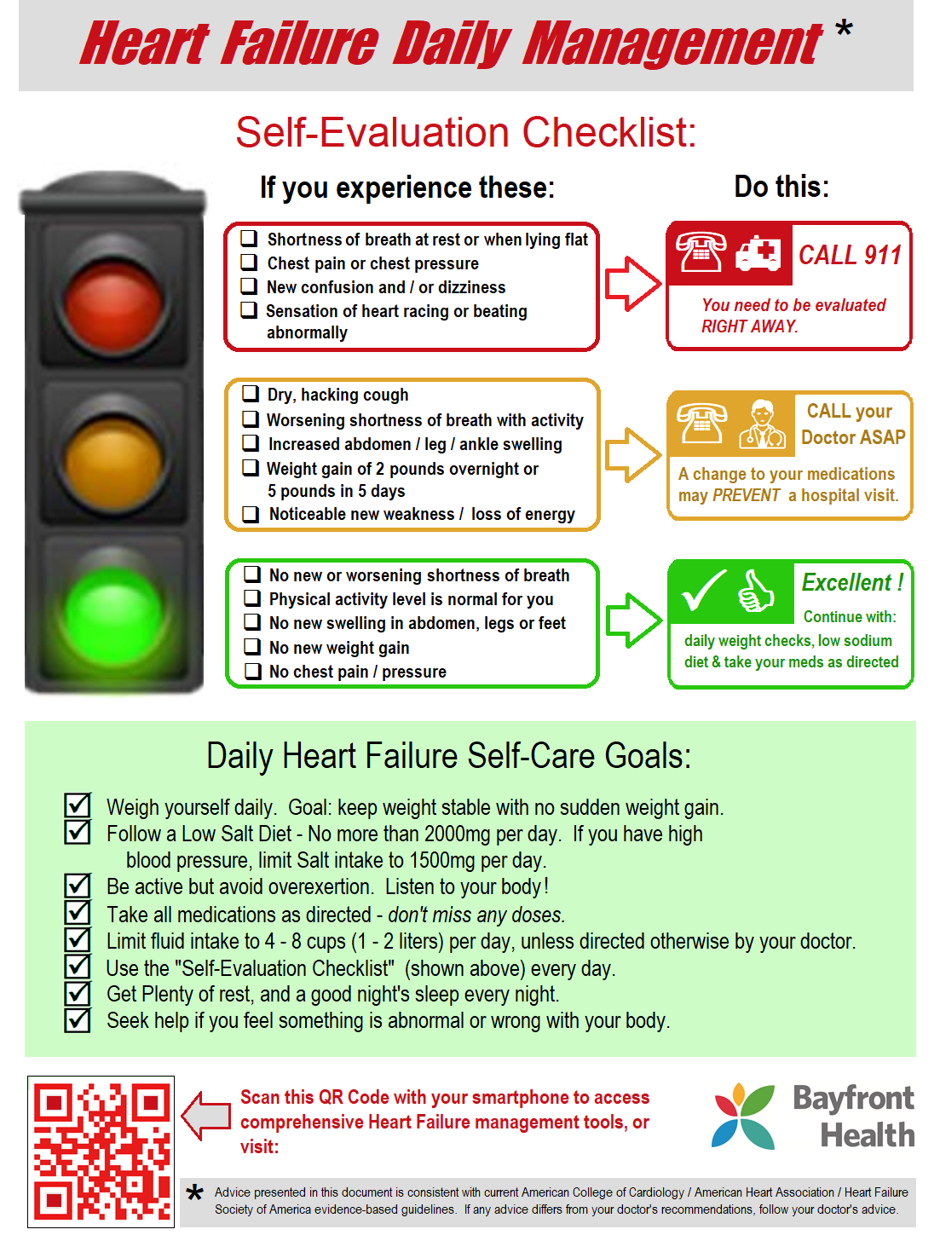
Guide for Grading of Pitting Edema:

Source: Healthline.com

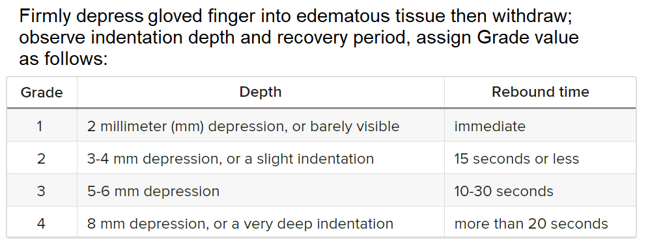

MEWS Score

Source: Research Square Article: “Applying the Modified Early Warning Score (MEWS) to assess geriatric patients in home care settings: A qualitative study of nurses and general practitioners experiences.”

